Để revert về những build cũ hơn bằng GUI thì ta dùng cách sau:

1. Navigate to repo’s page <https://github.com/minhqlrt/Training-materials>

2. Click on commits link

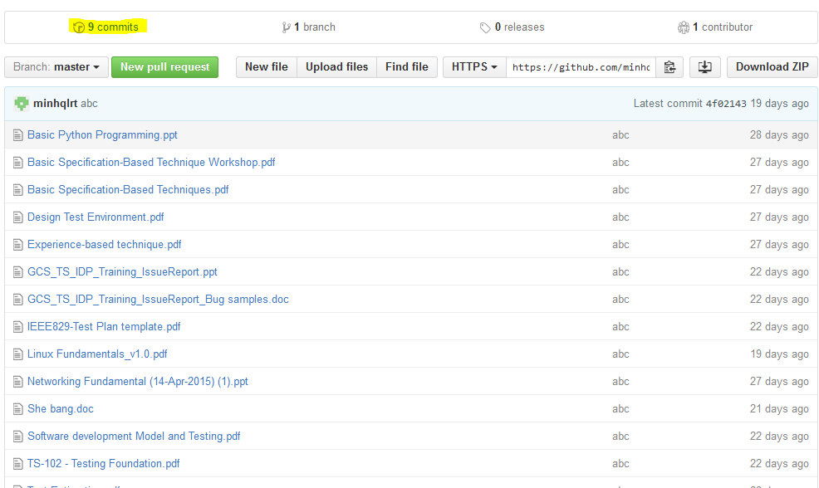

3. Click on Browse the repo of this point of history

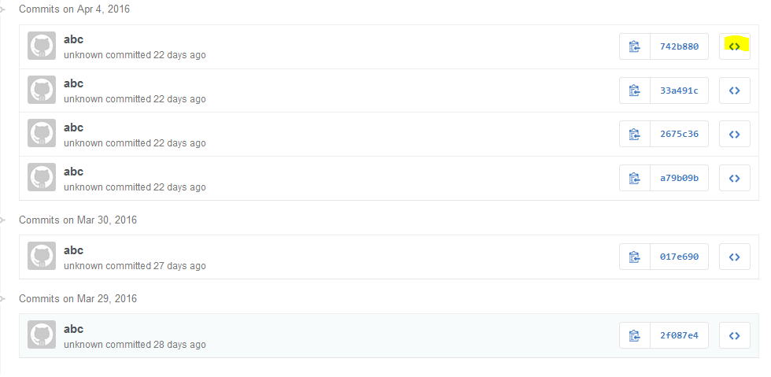

4. Click on Download Zip để download build cũ về